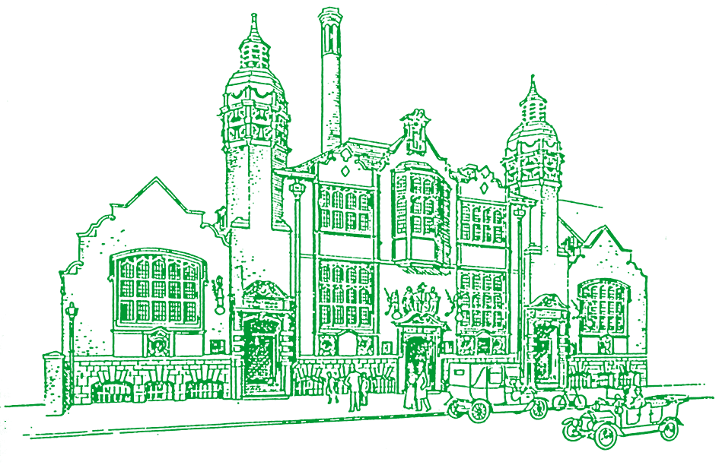 | Balsall Heath Local History Society | THE GAZETTE  MARCH 2020  Tel: 07565 194822 Email: info@balsallheathhistory.co.uk Web: balsallheathhistory.co.uk & www.thelostchildrenproject.uk Facebook: Balsall Heath Local History Society & The Lost Children Project
Meetings cancelled until further notice
Cancelled
Since there are to be many events cancelled due to the coronavirus precautions, there is no events diary this time. As things stand the next two meetings of the History Society are cancelled and more may follow. Those of you that have already seen last month’s newsletter will have seen notices for open days at St Alban’s Church and performances of the History Theatre Group’s new play “The Final Curtain Call”. All of these are now cancelled.
There have been plans for an event to celebrate the Malvern St farm’s 40th Anniversary but it is likely they will either be cancelled or postponed.
It’s Our 40th Birthday

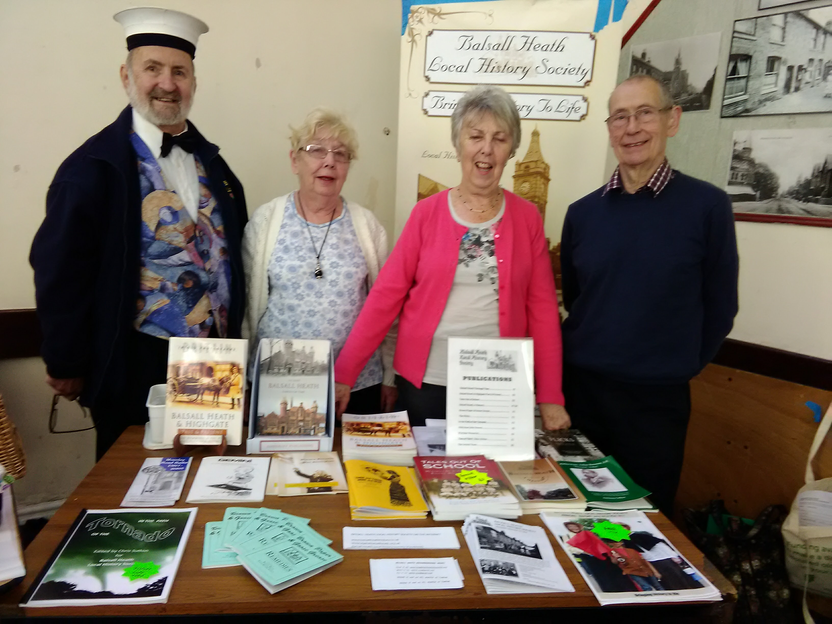

It’s been an amazing 40 years in Balsall Heath and the area has changed dramatically. The Local History Society has been active and thriving for all of them. It had its origins in the Workers Educational Association which held a series of meetings on local history. The Society itself was officially founded in April 1980.

The aims then were: to promote interest in the history of Balsall
Heath through organising public meetings, publishing material concerned with this area, gathering photographs and other documents and arranging exhibitions.

Over the years we have run many projects. One of our great achievements was to set up the Victorian Schoolroom in the old Clifton Junior School. This was visited by literally thousands of pupils not just from Balsall Heath but also the whole of the West Midlands. Unfortunately we have now had to close i.
Meanwhile monthly meetings have continued; a whole raft of publications have been produced; exhibitions have been held and we have contributed to Balsall Heath Carnival every year that it has run. We now also bring out a monthly newsletter, The Gazette, and have two websites and Facebook pages.
Our most recent project, The Lost Children, funded by the Heritage Lottery told the story of the Middlemore Emigration Homes founded in Highgate in 1873. This project has been a colossal success, both in Birmingham and internationally.
The major exhibition was held last year and the latest news is that the book, ”The Lost Children” is now available through our websites.
We plan to mark our birthday year with various events but Coronavirus is causing a delay to the celebrations

Mrs Neale. A working mother in 1896
I came across this in the Middlemore archives. It is an extract from the Application Book for the Homes. She was keeping herself and 5 children on ten shillings a week.
“My husband died 13 months ago. I have never troubled the parish. I have a young woman living with me who gives me 3 shillings a week. I have had to part with my furniture to keep us going. I go to work at 8 in the morning and come home at 8 at night.”
She said she was timid of taking another lodger and here she burst into tears.
Her 2 oldest sons at once began to weep with her. This sympathy in tears seems to be much more common in children of the very poor than children of the rich.
The poor woman added.” I cut bread and lard for the children before I go to work. The big boy cuts it for their dinner and again for tea. “
Three of her sons, William age 11, Alfred age 9 and Arthur age 7, were taken into the Homes and emigrated to Canada in 1896.
Val Hart

A Glorious New Roof for the Baths.
Moseley Road Baths is a much loved, internationally important historic masterpiece. Since opening in 1907, the Baths have been at the heart of Balsall Heath life – generations of local people have learned to swim here.. One of the oldest of only six Grade II* listed Baths in the country, the building contains some unique fixtures and fittings, including the only complete set of 46 private wash rooms (slipper baths) and steam drying racks in the country. The First Class or ‘Gala’ Pool has many of its original features including private poolside changing cubicles, spectator gallery and elaborate ironwork. In 2003, the Gala Pool was closed for swimming due to safety concerns and the space fell into disrepair.
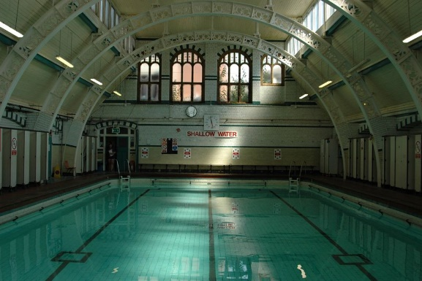
Moseley Road Baths was for many years under threat of closure and local people campaigned to keep their pool open. In 2016 a group of organisations came together to form a coalition, led by the National Trust. Working together, all organisations have contributed time, expertise and funding. Thanks to investment from Historic England and Birmingham City Council the restoration of the Gala Pool roof is now complete, and more repairs are on the way. Meanwhile swimming is still happening in the second pool thanks to the Coalition and a team of volunteers.
Lost Children Book
The Lost Children book has now been published but unfortunately is not yet available because of the Coronavirus emergency. It will go on sale through the website when possible.

